Relaxation Exercises:

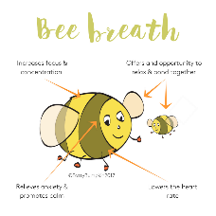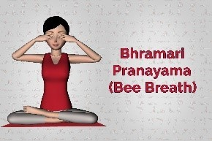 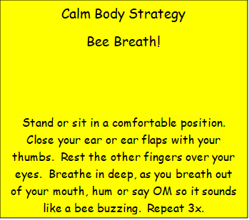

Calm Mind Strategy

Mindful Eating

As you eat lunch or breakfast today, be mindful about your food. Is it hard or soft? Does it have the same feel in your month? As you are eating, does the texture change? Does the food soften or melt?  
When you bite into the food, does it make a sound? Crunch? Loud or soft?  
Now for the taste? It is tangy? Sweet? Interesting?

